Name: _______________________________ Date: ____________________

Finding the equation of curves throughout life using quadratic regression

Goal
Generate a quadratic function given data that represents a parabola.

Objectives
- Given a picture of a curve, students will plot points of the curve and fill in a table.
- Given data points, students will input data into a graphing calculator and use the graphing calculator to perform a quadratic regression.

Materials
- Pictures from http://tylerlaufersweiler.weebly.com/curves.html
- Geometer’s Sketchpad
- Graphing Calculator
- Quadratic regression applet http://science.kennesaw.edu/~plaval/applets/QRegression.html

Procedure

- Open geometer’s Sketchpad.

- Pick a picture from http://tylerlaufersweiler.weebly.com/curves.html.

- Copy and Paste the picture into Geometer’s Sketchpad.

- Predict what the function might look like.

- Using the graph menu in Geometer’s Sketchpad, insert a coordinate plane.

- Move the origin to the appropriate spot of the curve. For example, move the origin to where the water is coming out of the spout, where the rainbow is coming out of the ground, etc. Adjust your scale so that your picture has more than 20 units.
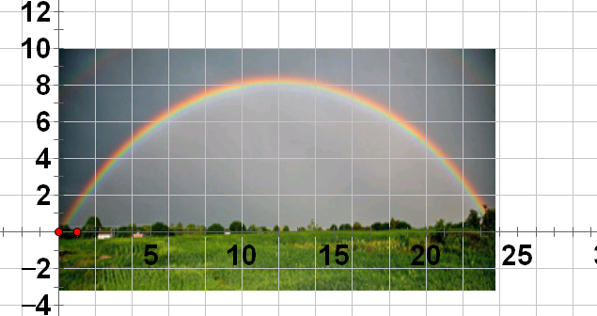
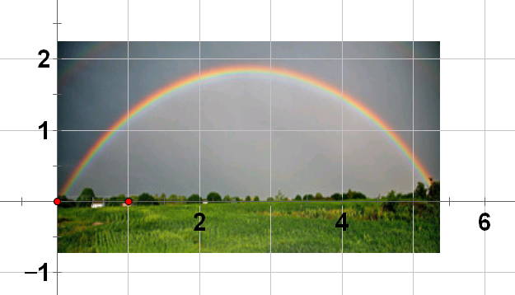
- Using the graph menu, plot between 10 and 20 points on the curve. Record these points in the table below.
x | y
1
2
3
4
5
6
7
8
9
10
11
12
13
14
15
16
17
18
19
20

- What type of regression would you use for these data points?
____________________________________________________________________________________

- Input data into the graphing calculator or quadratic regression applet.
- Using quadratic regression, record the values for a, b, and c.
$a$ = __________
$b$ = __________
$c$ = __________

$$f\left(x\right)=ax^{2}+bx+c$$

My quadratic function is_____________________________________________________________

- Go back to Geometer’s Sketchpad. Under the graph menu choose, plot new function. Plot your quadratic function. The quadratic plotted should follow along the path of the curve in the picture.

- Type your names on the graph and print it out.

